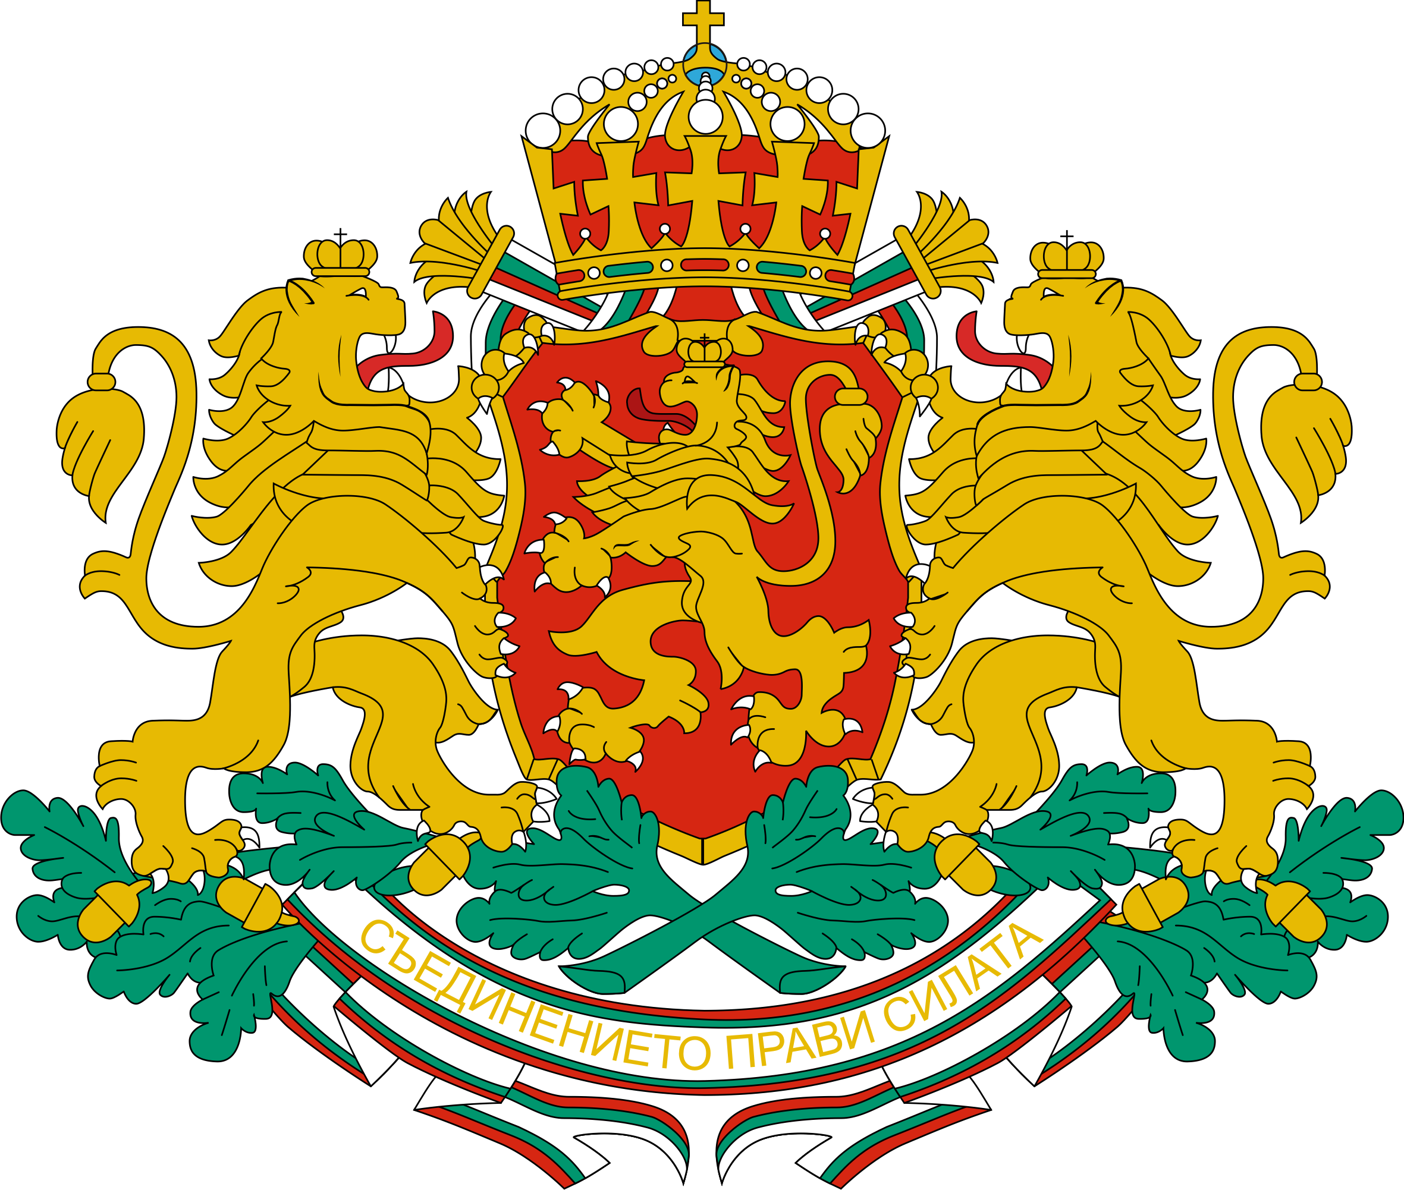 | CONSULATE GENERAL OF THE REPUBLIC OF BULGARIA  IN NEW YORK
NEWSLETTER – FEBRUARY 2024
You are welcome to the following events in and around New York, co-organized by the Bulgarian Consulate General in New Yor and/or including representatives of the Bulgarian community in the Northeastern US:
- February 3rd, 3.30 pm: Angela Rodel, the 2023 International Booker Prize-winning translator, will participate in a literary event at Columbia University “The Discreet Monsters of the Past”. She will be joined by Harriman Institute Director Valentina Izmirlieva, who will read the texts in her native Bulgarian. Address: Columbia University, Harriman Institute Atrium, 12th floor International Affairs Building, 420 W 118th St New York. Language: English.
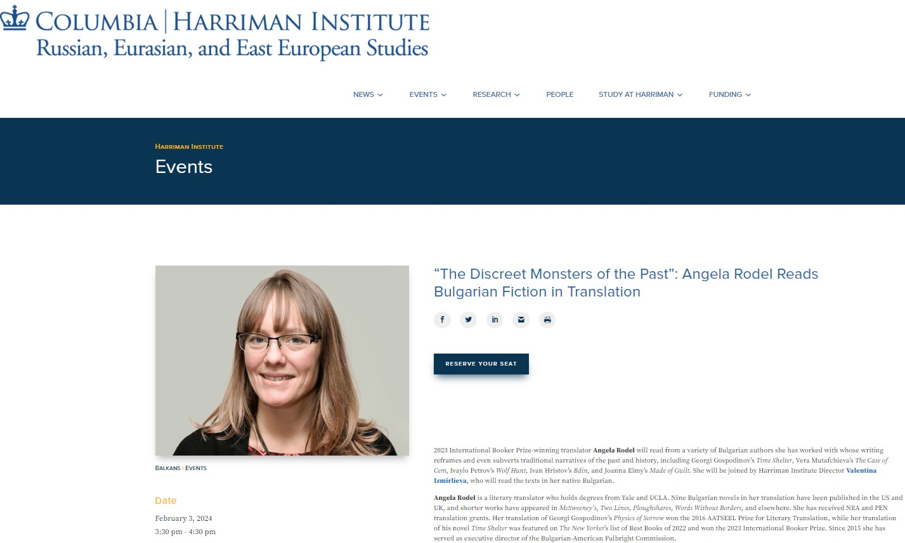

• February 3rd, 7.30 pm: A stand up comedy show “Тъп оптимист“ with Yavor Borisov. Language: Bulgarian. Address: Mehanata Bulgarian Bar, 113 Ludlow St., New York, NY 10002.
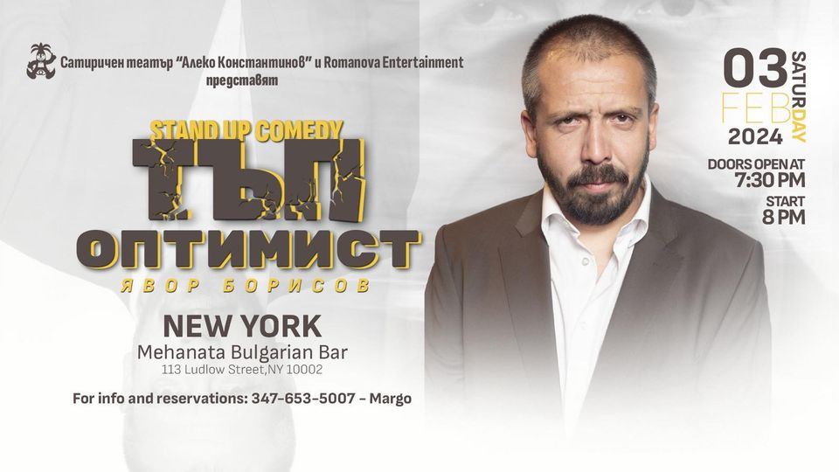

- February 3rd, 8.30 pm: A musical performance by Vlada Tomova and Yasna Voices. Language: English. Address: 85 Avenue A, New York, NY 10009.

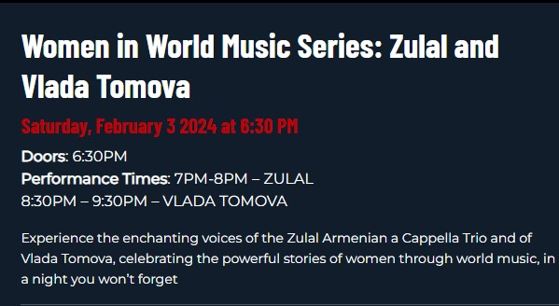

- February 4th, 3 pm: Bulgarian Folk Dance Shop, organized by Bulgarian School Hristo Botev, New York. Address: 315 W 18th St, 6 fl. NY, NY 10011.
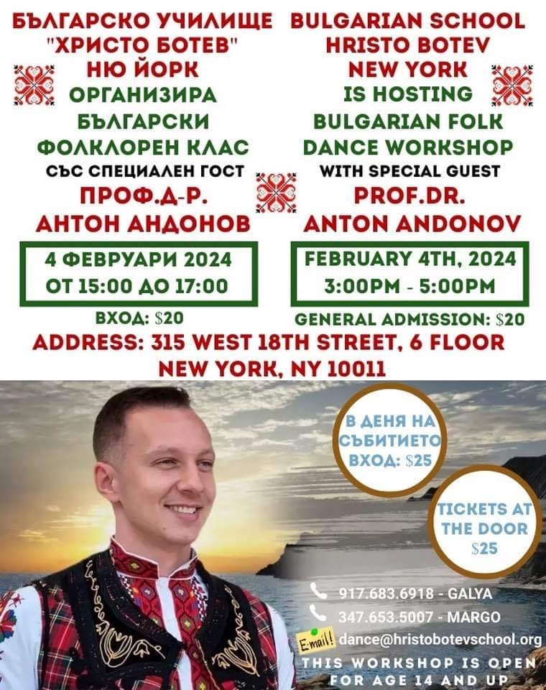

- February 7th, 7 pm: Bulgarian Dance Party. Come dance to the bagpipe! Lubomir Smilenov - gaida, gadulka, Michael Ginsburg – tupan. Brief instruction for the dances. Address:213 E 82nd St, NY, NY 10028. Info: 646-831-8720 85.
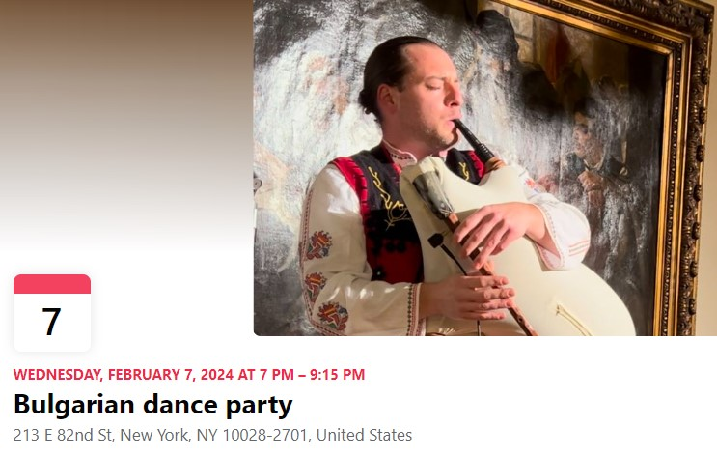

- February 11th, 4 pm: Sofia Philharmonic in New York. Language: English. Address: Lehman Center, 250 Bedford Park Blvd West, Bronx, New York 10468.

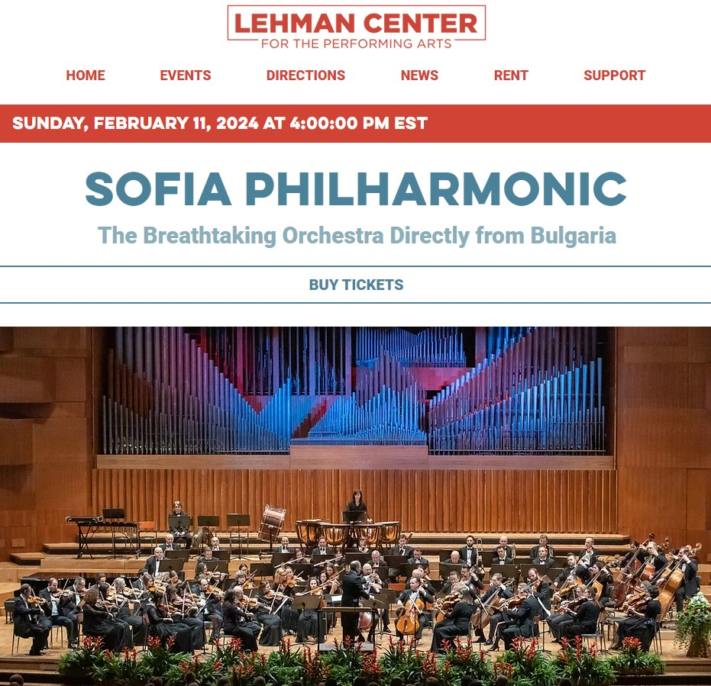

- February 14th, 6:30 pm: Flute and Piano Duets, organized by Bulgarian Concert Evenings in New York. Performers: Lora Al-Ahmad, piano and Maron Khoury, flute. Book at https://www.bceny.org/season-2023-24. Address: Consulate General of Bulgaria in New York, 121 E 62nd St, New York. Language: English.
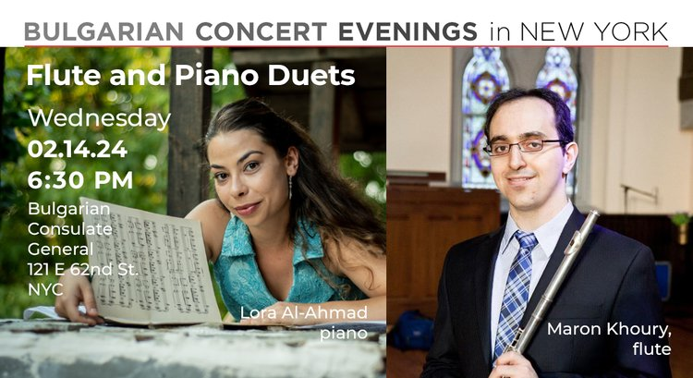

- February 15th, 7 pm: A Comedy Show of Mihail Bilalov. Language: Bulgarian. Address: 590 Main St., Melrose, MA.
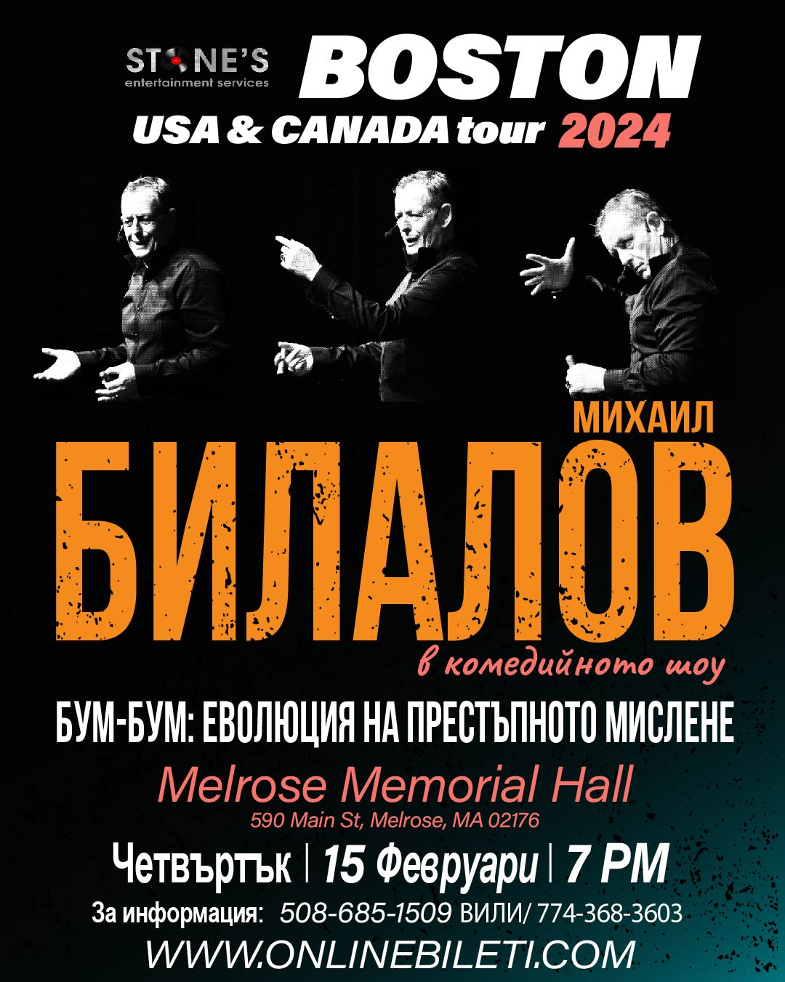

- February 16th, 6 pm: Horoteka NYC with Elissaveta and Guergana. Address: KTown Dance Studio, 38 W 32nd St, New York, NY 10001.
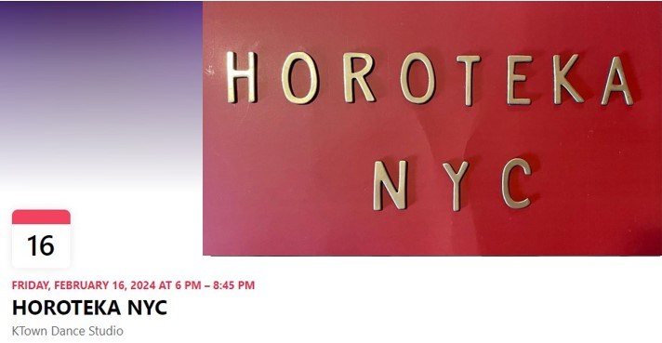

- February 17th, 7 pm: Sofia Philharmonic in New Jercy. Language: English. Address: State Theatre New Jersey, 15 Livingston Avenue New Brunswick, NJ 08901.
